Integration Manual
Deploying the SpecterX SharePoint Connector



Introduction
This guide will walk you through the process of deploying the SpecterX SharePoint Connector in your Microsoft 365 tenant using the SharePoint App Catalog.
Once deployed, the connector enables SpecterX to securely interact with your SharePoint Online environment and apply protection, audit logging, and policy controls.

You can install the app at the tenant level or deploy it to specific site collections as required.
Note: Remember to consult with your system administrator or IT department if you encounter any issues or if this configuration impacts other systems.

Step 1 - Open the SharePoint Admin Center
- Sign in to the Microsoft 365 Admin Center using a Global Admin or SharePoint Admin account.
- Navigate to:
Show all → Admin Centers → SharePoint
- In the left-hand navigation menu, select:
More features → Apps → Open
You will now see the Apps administration screen and the link to the App Catalog.

Step 2 - Access or Create the App Catalog
If your organization already has an App Catalog:
- Click Open under App Catalog.
If you do not have an App Catalog yet:
- Click Create a new app catalog site.
- Fill in the required fields (Title, URL, Administrator).
- Click OK to provision the App Catalog.
(This may take several minutes.)
- Once the App Catalog is ready, proceed to upload the SpecterX connector package.

Step 3 - Upload the SpecterX SharePoint Connector App
- In the App Catalog, open the Apps for SharePoint library.
- Click Upload and select the .sppkg file provided by SpecterX.
- Once uploaded, SharePoint will display a prompt asking whether to trust this app.
- Review the listed permissions and click Deploy.
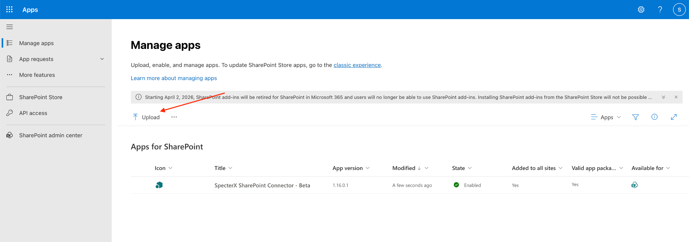
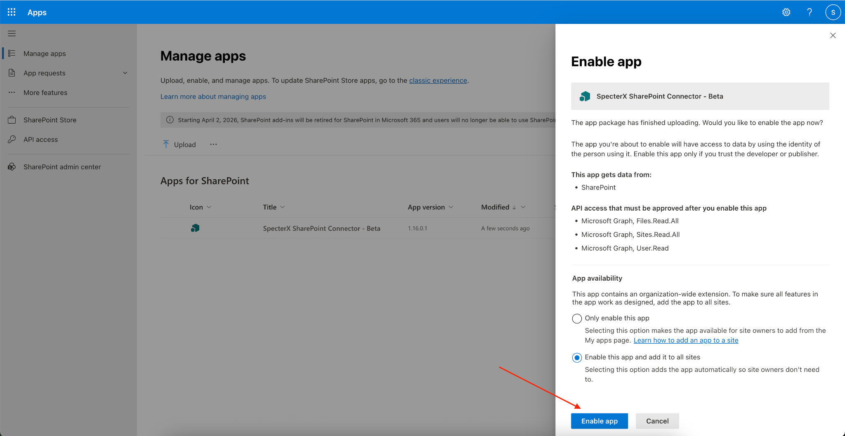
- If the app requests special API permissions (Graph, Teams, etc), a Global Admin must approve. Until approved, the app won’t be usable.
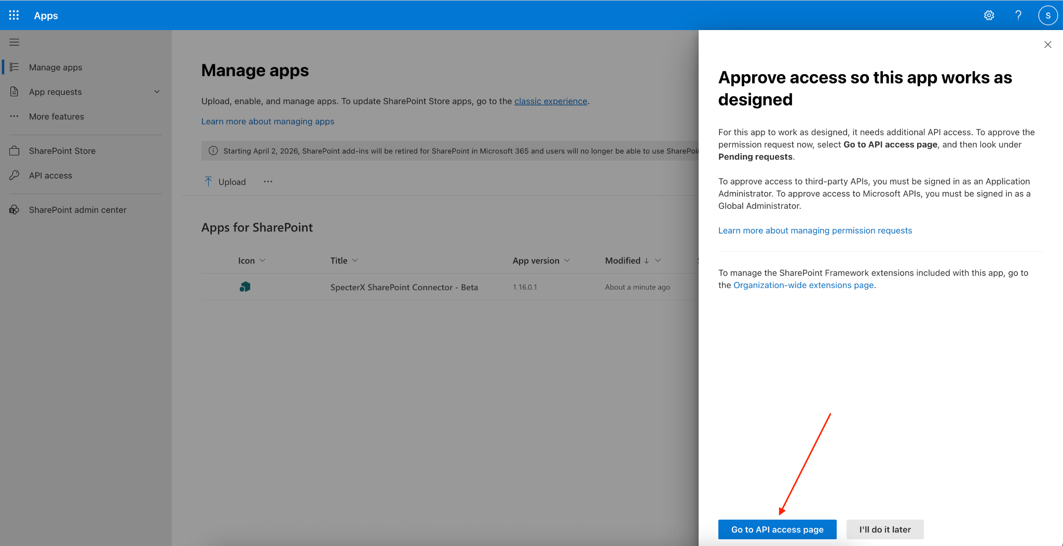
Note: Deployment makes the SpecterX Connector available to site collections across the tenant. You can manage which sites receive the app in the next steps.
If a SpecterX Connector is already installed (upgrade scenario), make sure to select Replace when prompted to update the existing connector.

Step 4 - Configure Deployment Scope (Optional)
After deployment, you can determine whether the connector is:
- Available to the entire organization
- Deployed automatically to all site collections
- Deployed only to selected site collections
To configure:
- From the App Catalog, select the newly-uploaded SpecterX Connector.
- Click the Site Contents → App Deployment option (if available).
- Choose one of the following:
  - Deploy to all sites (recommended for standard deployments)
  - Deploy to selected sites only
- Click Enable to finalize the deployment.

Step 5 - Approve API Permissions
- Navigate to:
Microsoft EntraID Admin Center → Identity → Applications → Enterprise Applications
- Locate SpecterX SharePoint Connector.
- Open Permissions.
- Click Grant admin consent if prompted.
This ensures the connector can read metadata, access files for protection workflows, and operate according to SpecterX policies.
Note: If SpecterX SharePoint Connector does not appear in the list, create it manually:
New application → Create your own application → Integrate any other application you don’t find in the gallery (Non-gallery application) → Create
After creating it, return to this step and grant the required permissions.

Step 6 - Validate Installation
Once deployed:
- Open any SharePoint site (or the specific site you deployed the app to).
- Select Settings → Site Contents.
- Confirm the SpecterX SharePoint Connector appears in the list of installed apps.
- If required by your deployment, activate the app for the site by clicking it once.
Users should now be able to work normally while the “Share Using SpecterX” button is added within the SharePoint UI.

You’ve Successfully Deployed the SpecterX SharePoint Connector within your SharePoint tenant.
The connector is now active in your SharePoint Online environment.
Users can continue their regular workflows while the “Share Using SpecterX” functionality is added.
For future updates or changes:
- You can remove or redeploy the app from the App Catalog.
- You can adjust access and API permissions in Entra Admin Center.
- You can update enforcement logic in the SpecterX Admin Console.

Step 7 - Configure SharePoint App Registration - Service Account

- Create App Registration in Microsoft Entra ID
  - Go to Azure Portal - https://portal.azure.com/
  - Navigate to App Registrations - Click New registration
  - Fill in: Name (any), Supported Account Types (Single tenant), Redirect URI (leave empty)
  - Click Register, after creation copy: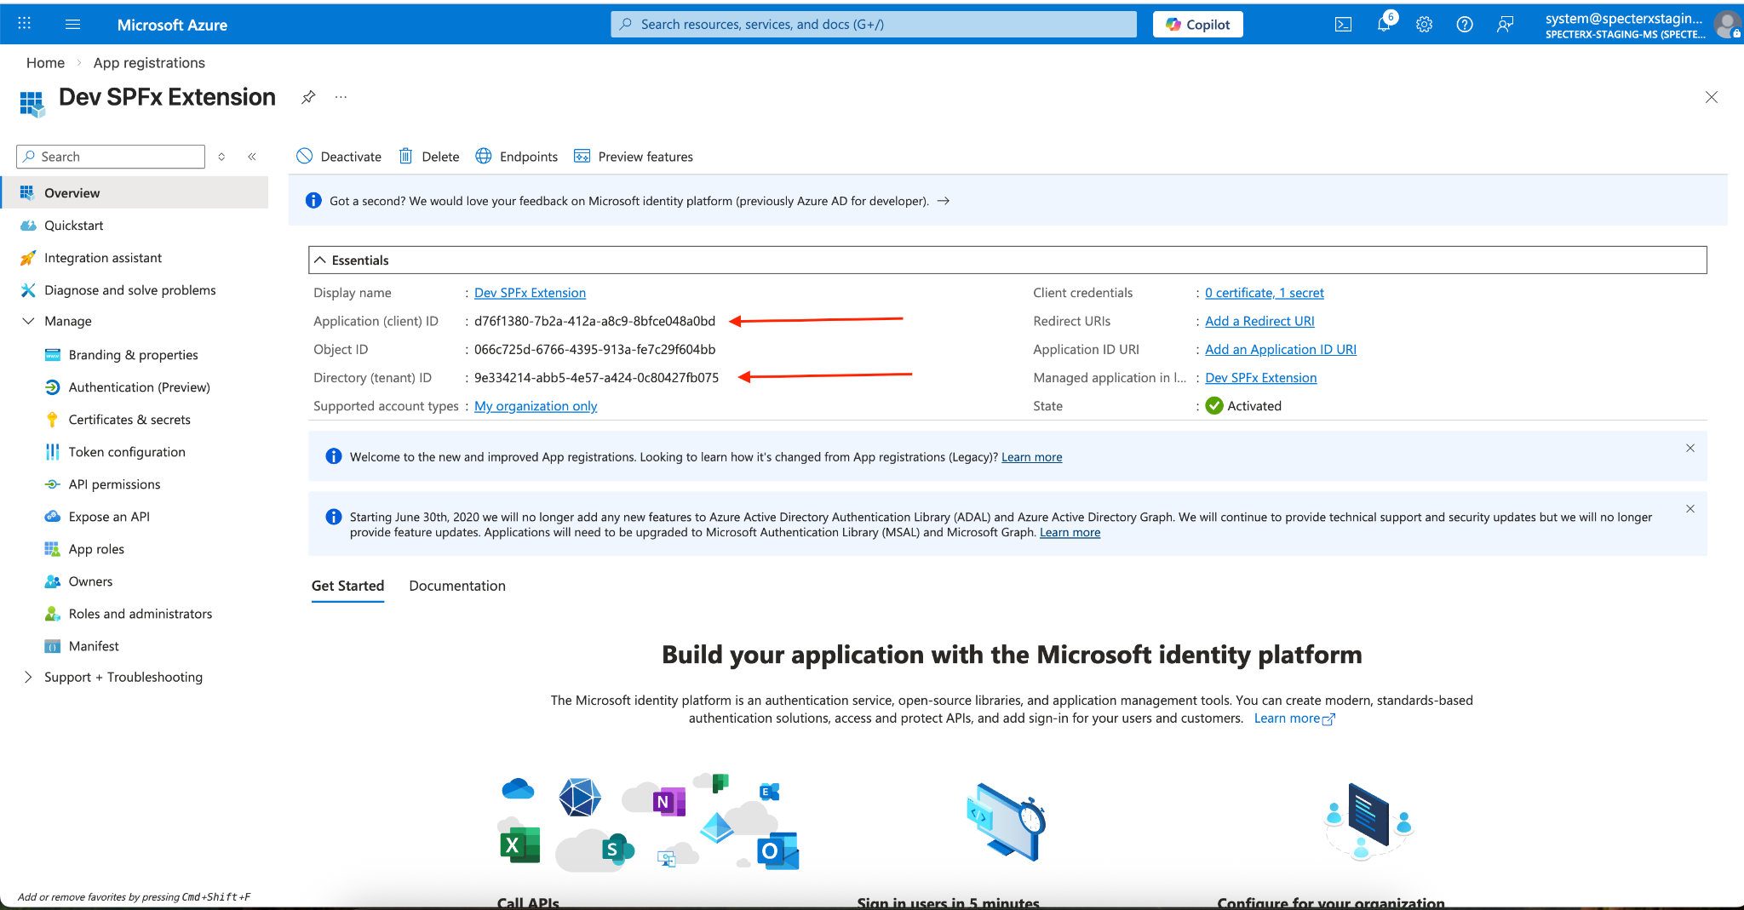
    - Directory (tenant) ID → TENANT_ID
    - Application (client) ID → CLIENT_ID
- Create Client Secret
  - Inside the App go to Certificates & Secrets
  - Click New client secret
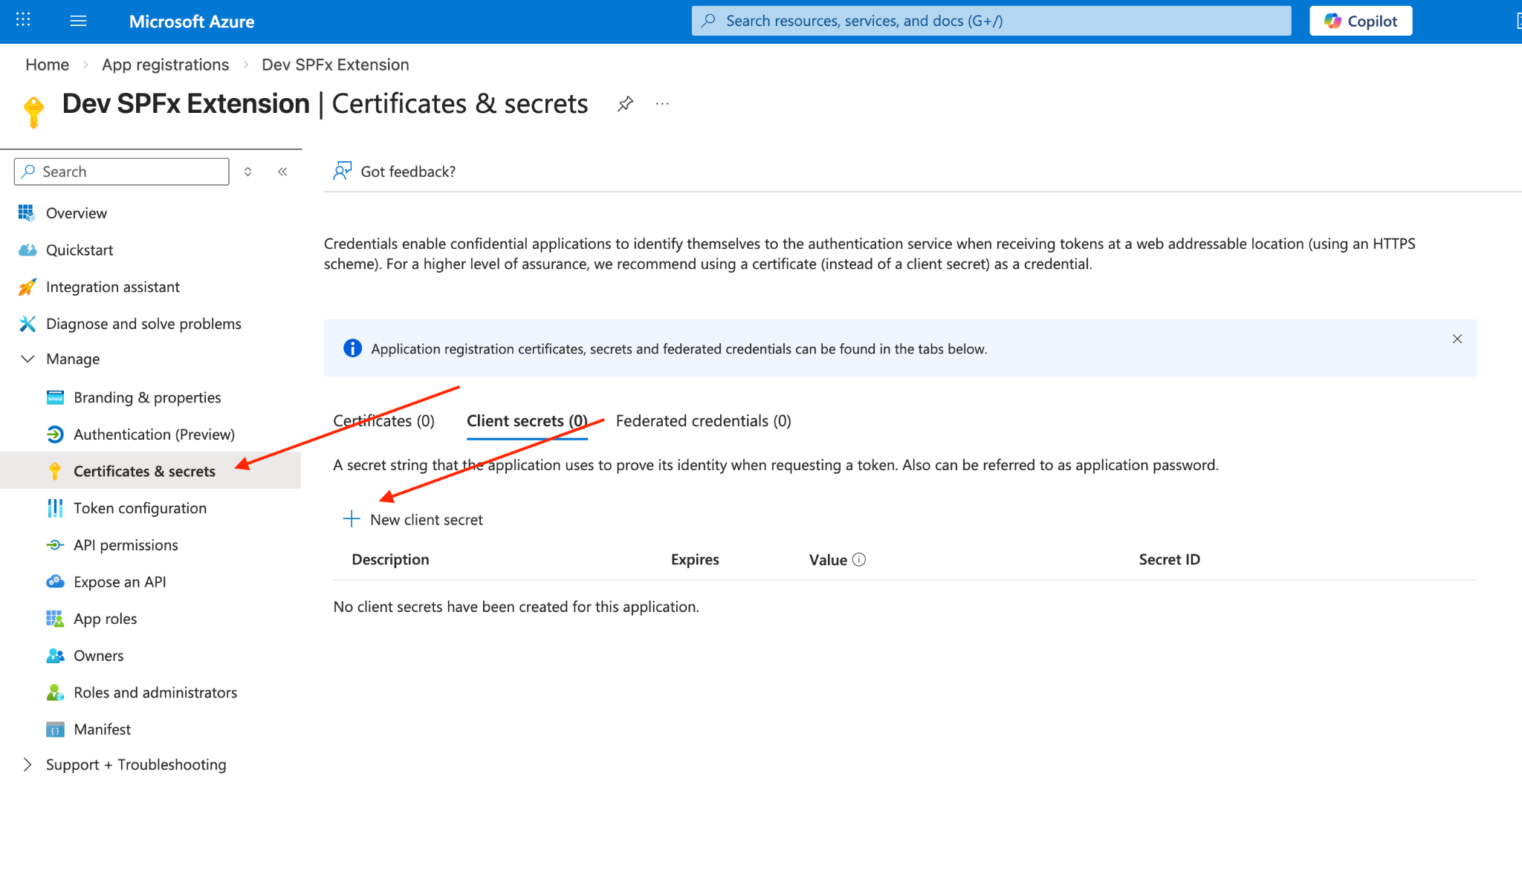
  - Add description and expiration period
  - Click Add
  - Copy the value immediately → CLIENT_SECRET
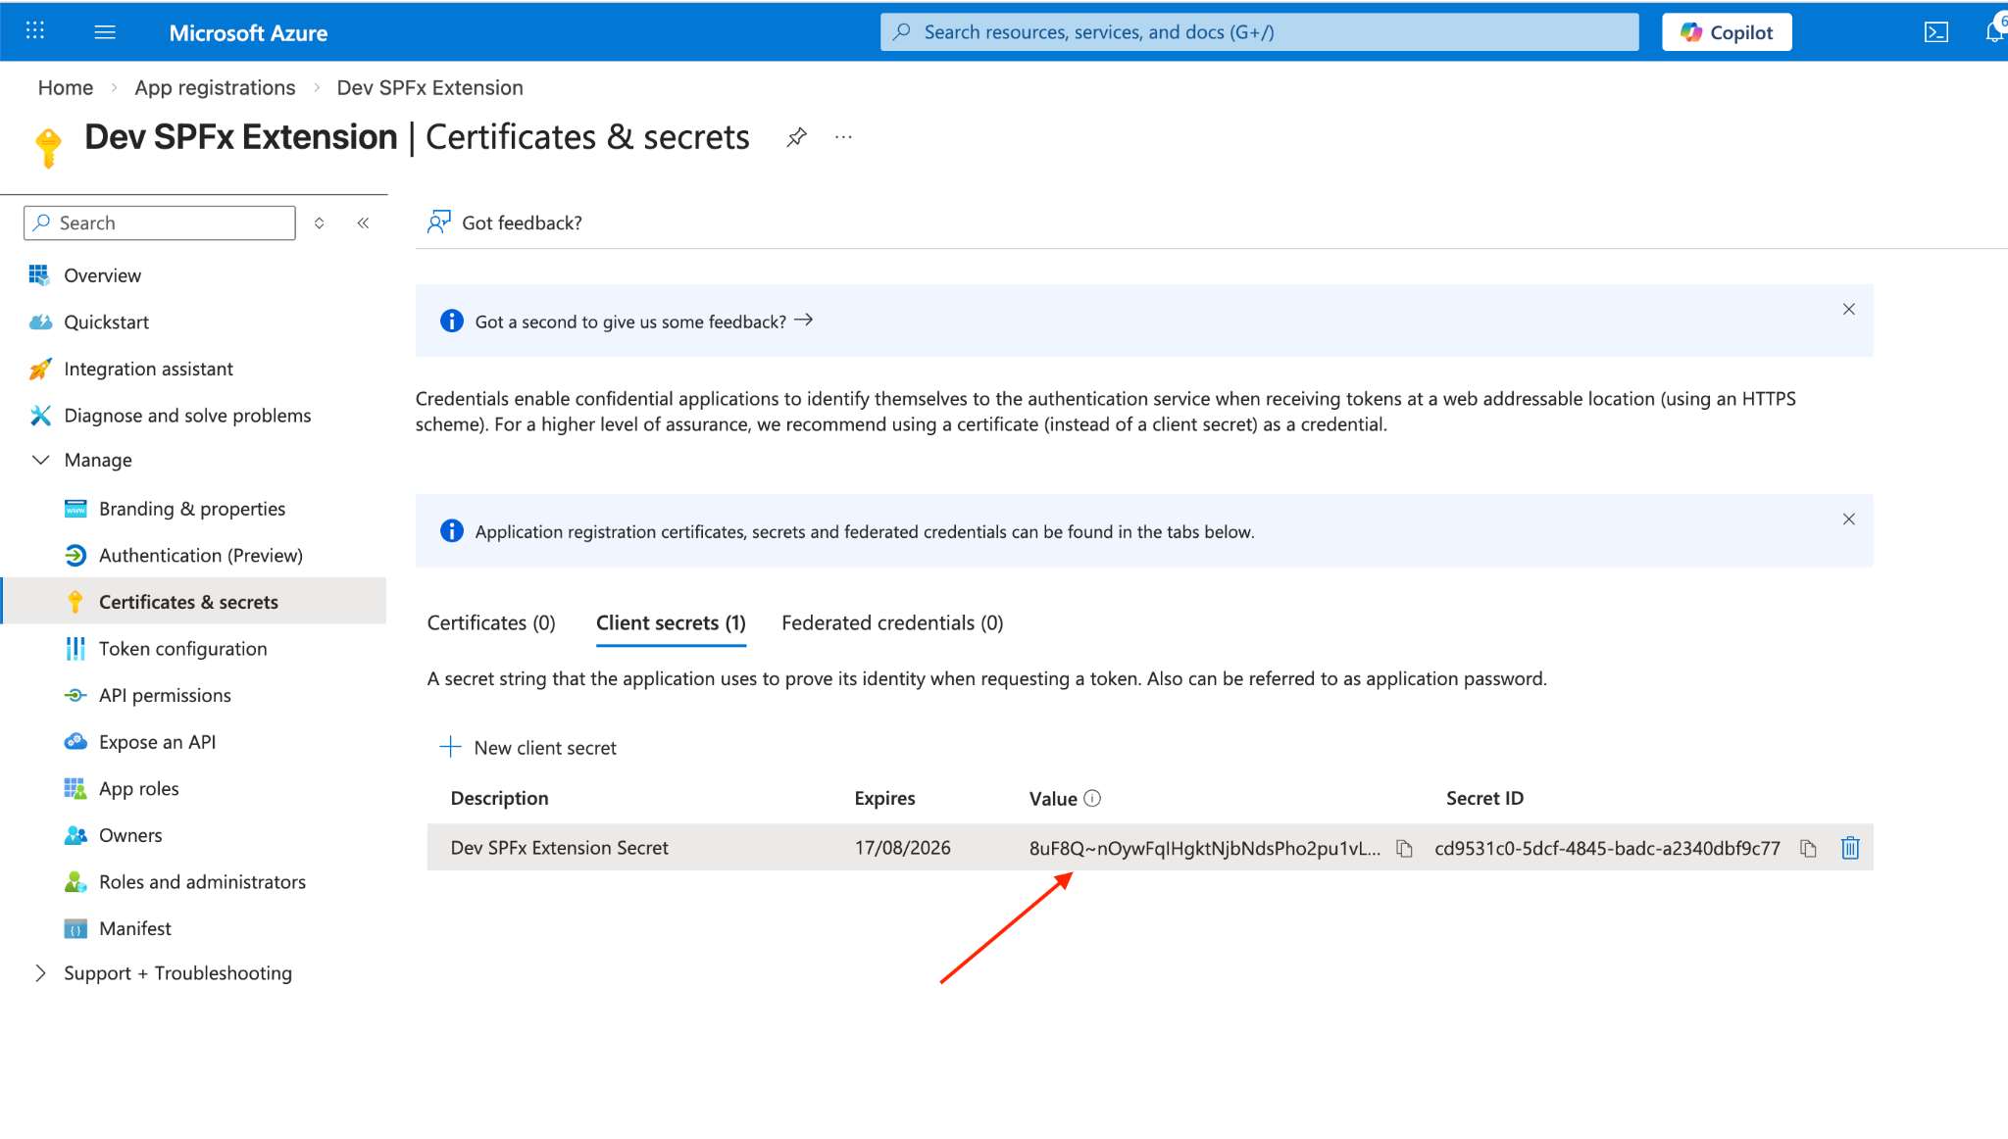

- Add API Permissions and Grant Admin Consent
  - Go to API permissions and Click Add a Permission
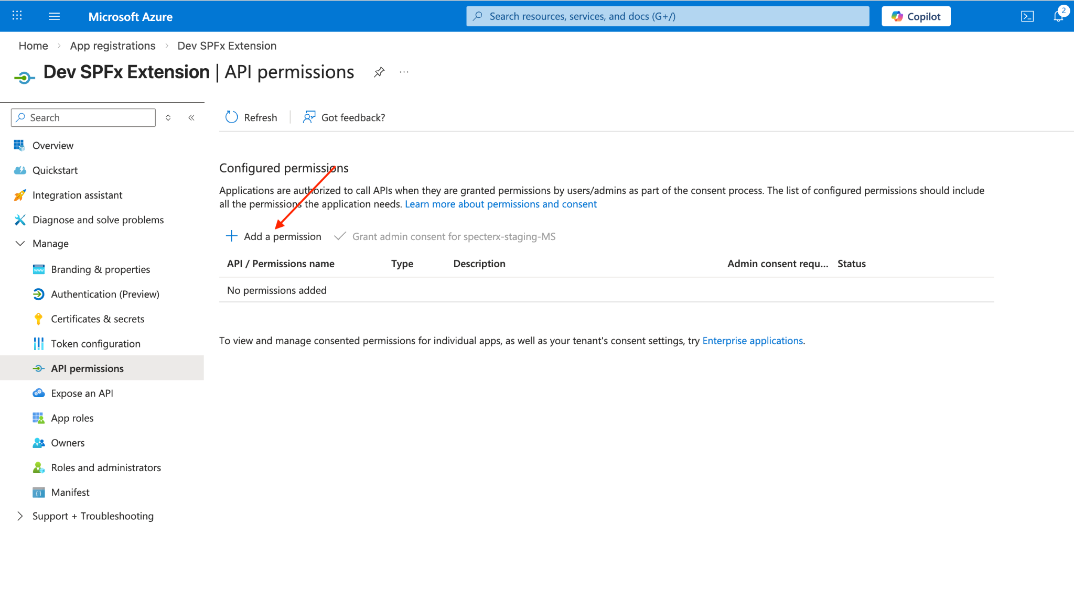
  - Select Microsoft Graph and Choose Application Permissions
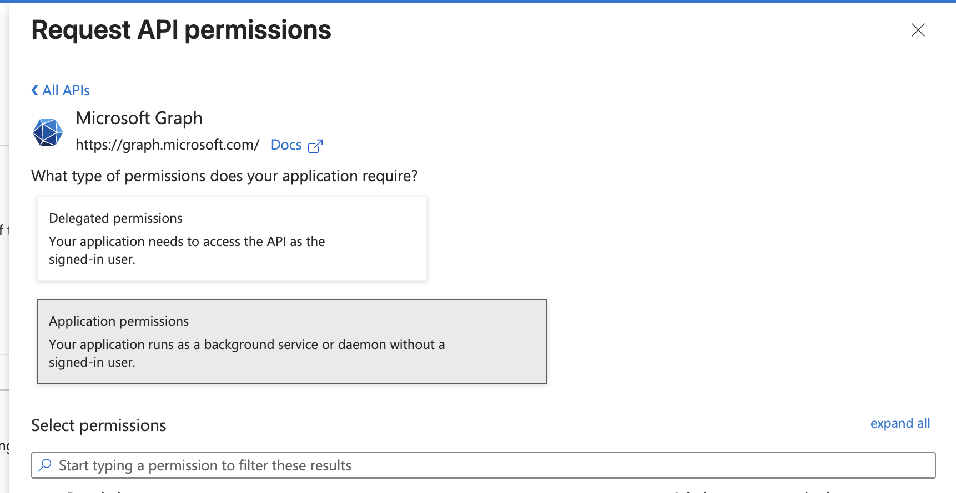
  - Search and add: Files.Read.All & SensitivityLabels.Read.All
  - Click Add permissions
  - Click Grant admin consent for <Tenant Name> for both permission sets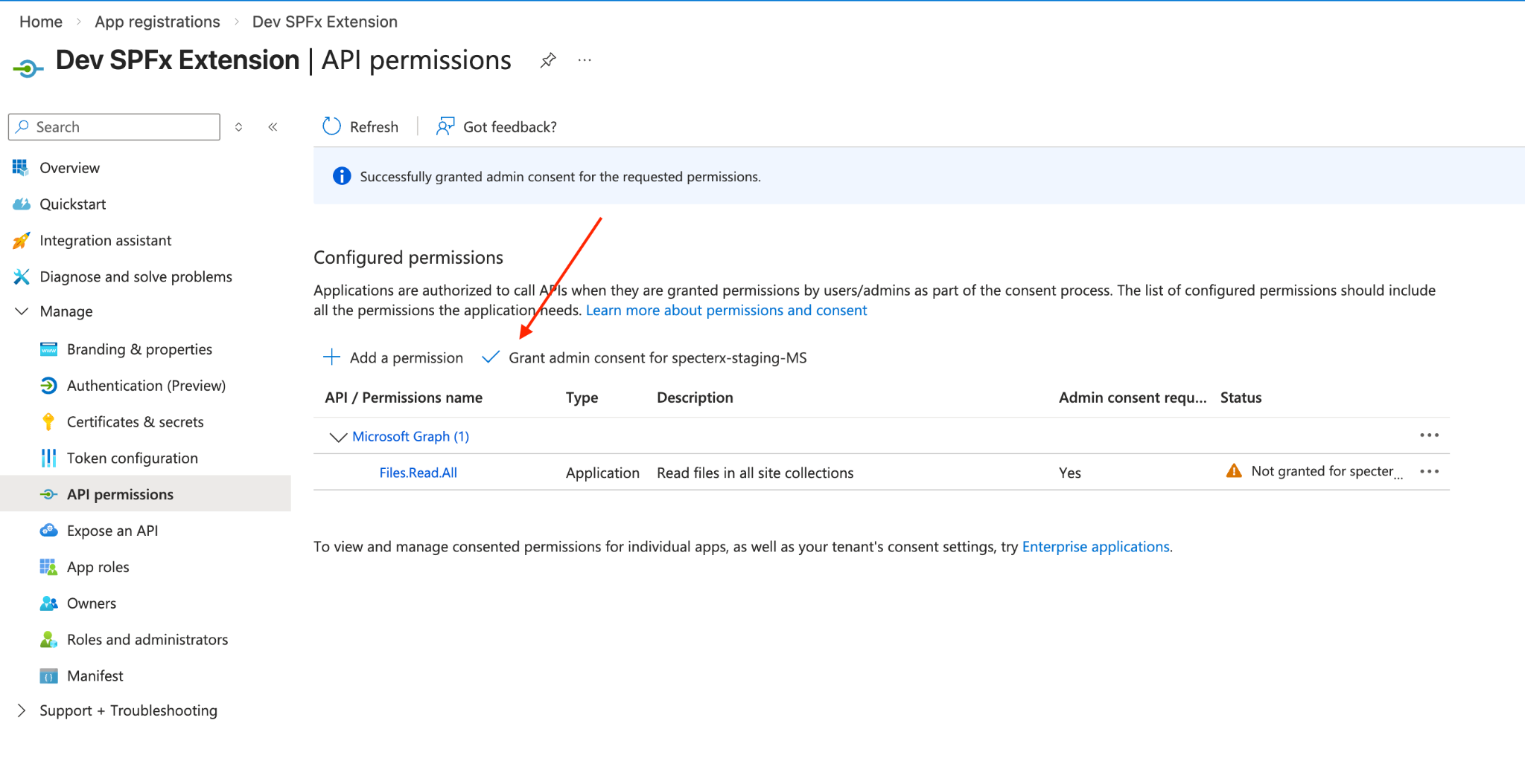
  - Confirm both and verify that status shows: ✅Granted for <Tenant Name>
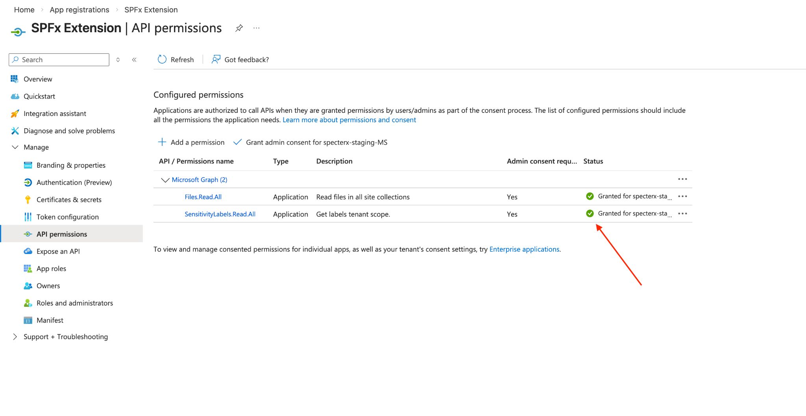

- Provide Credentials to SpecterX
  - Open Settings tab as Admin
  - Choose SharePoint Connector
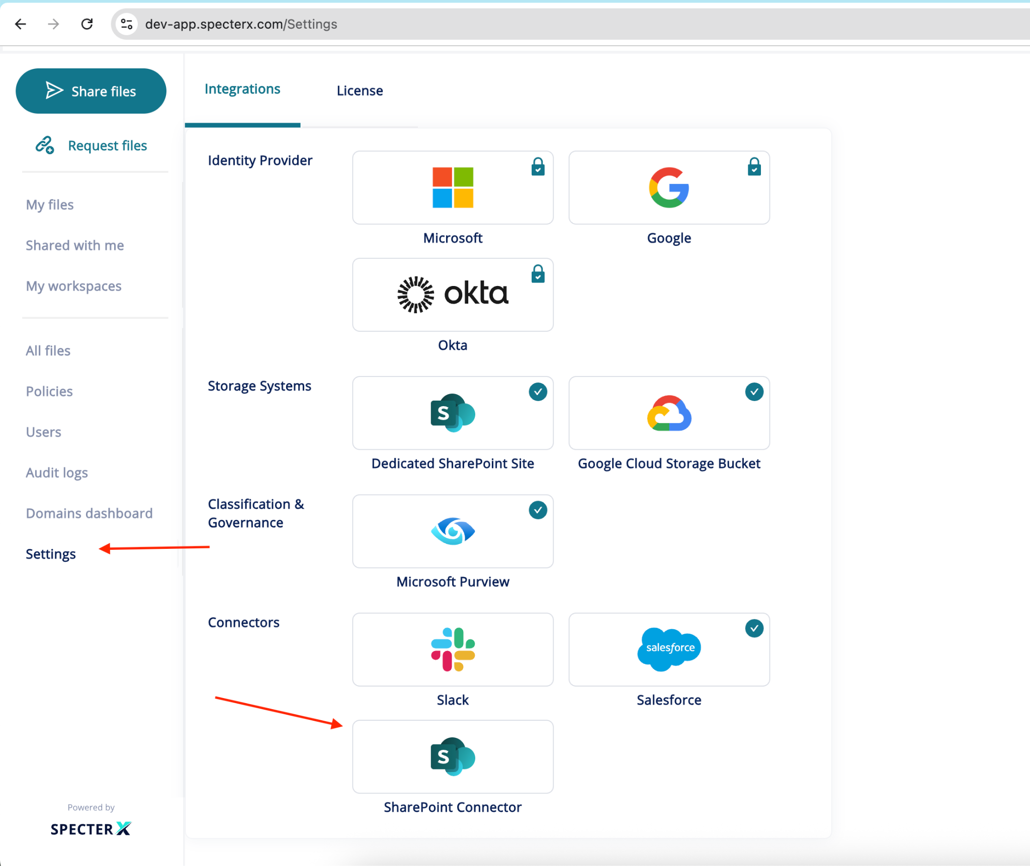
  - Fill in TENANT_ID, CLIENT_ID and CLIENT_SECRET
  - Save configurations
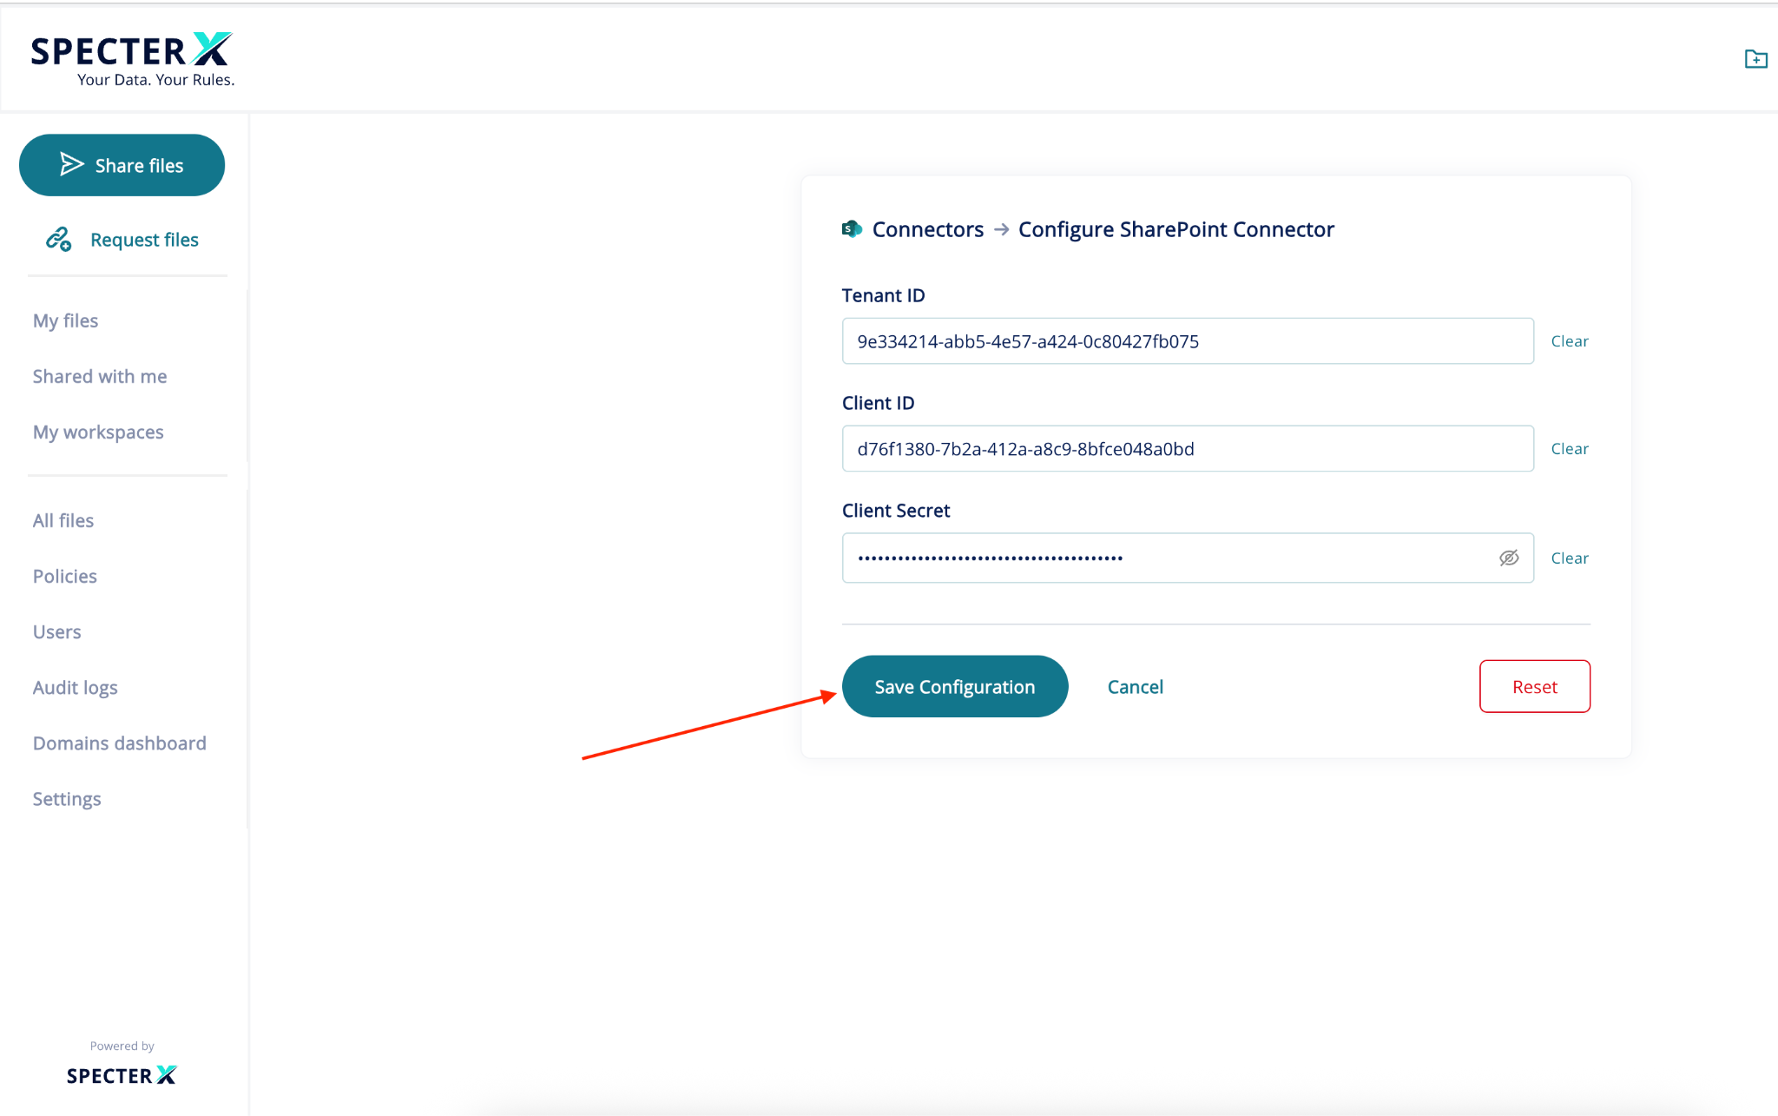

If you encounter any issues, contact us at support@specterx.com.

